Lab 11

1. Answer questions about the graph G = (V,E) displayed below.
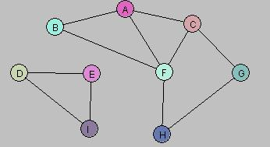

  - Is the graph G connected? If not, what are the connected components for G?
Solution:
The graph is not connected here as there is not complete path. There are total two connected components here i-e (D,E,I) and (B,A,C,F,H,G)

  - Draw a spanning tree/forest for G.
Solution:
As its not a connected graph so it is Spanning forest and
T={(FB),(FA),(FC),(FH),(CG),(DE),(EI)}
  - Is G a Hamiltonian graph?
    - Solution:
          - Hamiltonian graph is a graph which contains a Hamiltonian cycle. As it doesn’t contain any simple cycle so it’s not a Hamiltonian graph.

  - Is there a Vertex Cover of size less than or equal to 5 for G? If so, what is the Vertex Cover?
Solution:
As to this spanning forest the vertex cover size is equal to 5 which covers at least one endpoint in the set C.so set C is {D,E,F,A,G}
- Hamiltonian Graphs. The following graph has a Hamiltonian cycle. Find it.
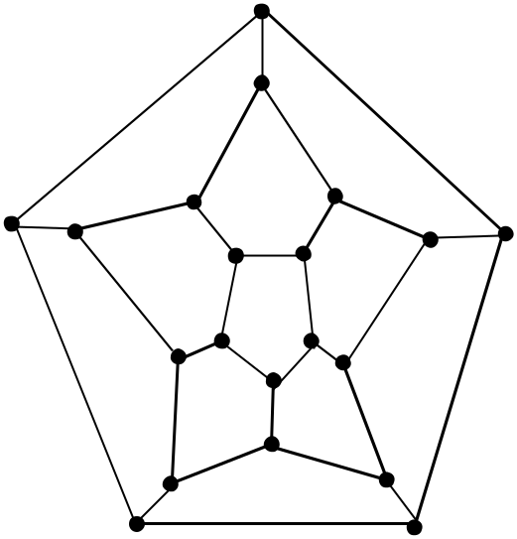
Solution:
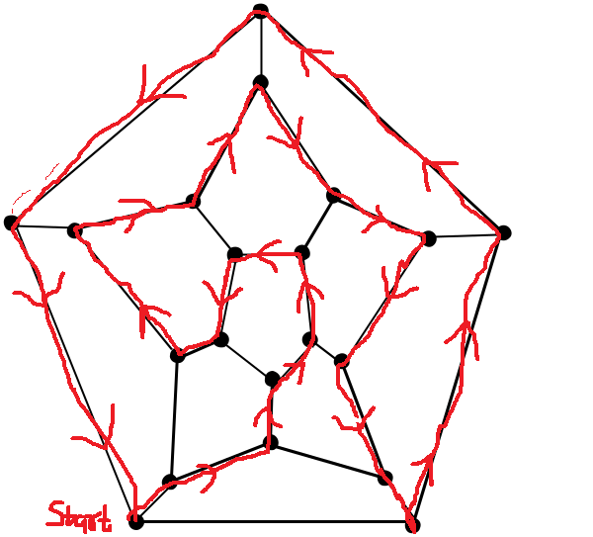

- Vertex Covers. Create an algorithm for computing the smallest size of a vertex cover for a graph. The input of your algorithm is a set V of vertices along with a set E of edges. Assume you have the following functions available (no need to implement these):

  - computeEndpoints(edge) – returns the vertices that are at the endpoints of the input edge

  - belongsTo(vertex, set) – returns true if the input vertex is a member of the given set

Hint: Loop through all subsets of V. For each subset W, check to see if W is a vertex cover. Do this by looping through all edges; for each edge e, check to see if at least one of its endpoints lies in W.
Solution:
As according to the brute force solution
First, we make all the powersets of All vertices.
Then iterate through all the subsets of V and see if every powerset is a vertex cover or not and check that the size of previous vertex cover is greater than the new one. If yes then replace the new Vertex Cover with the new one. andg then return the minimum size of the Vertex cover

Algorithm Vertex Cover(V,E)
Input: A graph g with vertices V and number of edges E.
Output: Size of the minimum vertex cover

pow←PowerSet(V)
minVertex←V
minLength←|V|
Foreach set in pow
isVertex←true
//Verify that set is a VertexCover
Foreach edge in Edge do
(u,v)←computeEndPoints(e)
If(!belongsto(u,set) and !belongsto(v,set)
isVertex=false
if(isVertex and set.size()<minVertex.size()) then
minVertex←set
minLength←|set|
return minLength

We can also solve this by Greedy method where we select the highest power of edges vertex and then remove all its adjacent edges and continues to do so until all edges are removed.and return the set length.
- Graph Implementation. Use the BFS class to solve the following problems. Implement by implementing the unimplemented methods in the Graph class.
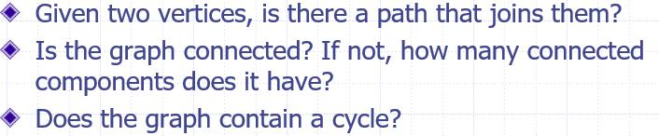

Solution:
- public class PathExists extends BreadthFirstSearch {
boolean isExists = false;
Vertex targetVertex;
public PathExists(Graph graph) {
super(graph);
}

@Override
protected void processVertex(Vertex w){
if(targetVertex.equals(w)){
isExists = true;
}
}

//TO-DO
public boolean pathExists(Vertex u, Vertex v) {
targetVertex = v;
start(u);
return isExists;
}

}
b)
public class IsConnected extends BreadthFirstSearch {
int noOfComponents = 0;

public IsConnected(Graph graph) {
super(graph);
}

@Override
protected void additionalProcessing() {
//by default do nothing
noOfComponents++;
}

//TO-DO
public boolean isConnected() {
start();
if(noOfComponents>1){
return false;
}
return true;
}
}
c)
public class HasCycle extends BreadthFirstSearch {
private ArrayList<Edge> tree = new ArrayList<Edge>();
public HasCycle(Graph graph) {
super(graph);
}

protected void processEdge(Edge e) {
//override for needed functionality
tree.add(e);
}

//TO-DO
public boolean hasCycle() {
start();
​return this.graph.edges.size() > tree.size() ;
}
}

- Implement a subclass ShortestPathLength of BreadthFirstSearch that will provide, for any two vertices x, y in a graph G, the length of the shortest path from x to y in G. (You can assume G is connected.) Use the ideas mentioned in the slides for your implementation. Be sure to add a method of the Graph class having the following signature:

int shortestPathLength(Vertex u, Vertex v) which will make use of your new subclass.

Solution:
public class ShortestPath extends BreadthFirstSearch {
private HashMap<Vertex, Integer> levelsMap = new HashMap<Vertex, Integer>();
private HashMap<Vertex, Vertex> parentMap = new HashMap<Vertex, Vertex>();

/** Assumes g is connected */
public ShortestPath(Graph g) {
super(g);

}

@Override
protected void processEdge(Edge e) {
//override for needed functionality
parentMap.put(e.u,e.v);
levelsMap.putIfAbsent(e.v,0);
levelsMap.put(e.u,levelsMap.get(e.v)+1);
}

@Override
protected void processVertex(Vertex w){
//should be overridden; by default, do nothing
super.processVertex(w);
}

//TO-DO
public int computeShortestPathLength(Vertex s, Vertex v) {
start(s);
return levelsMap.get(v);
}
}

